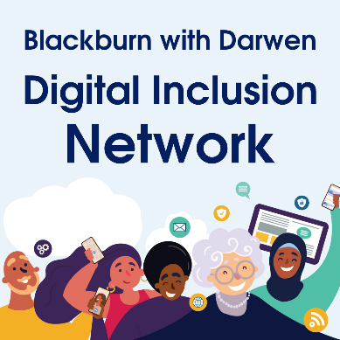
Digital Skills Survey
The Digital Inclusion Network – the Council and local partners – want to find out about what support people in Blackburn with Darwen would like with their digital skills - to get online and be more confident using the internet.
Please take just a few minutes to complete this short survey. It will help us build on the support we can provide locally and help to shape future services and opportunities that promote digital skills.
You can complete this form on behalf of someone else. There are questions at the end which allow you to tell us more about yourself, or the person you are completing on behalf of.
1.Which of the following apply to you? (tick one)
1.1 I go online as much as I want
1.2 I go online but want to do it more
1.3 I do not go online and do not want to
1.4 I do not go online but want to

2. Which of the following apply to you? (tick all that apply)
2.1 I own or have regular access to a device (i.e. laptop, tablet, mobile phone) that meets / could
meet my online needs
2.2 I own or have regular access to a mobile internet connection that meets my online needs
2.3 I own or have regular access to a broadband internet connection that meets my online needs
2.4 I have the knowledge and skills to do most things I need to online
2.5 I am confident to do most things l need to, online
2.6 I depend on others to do things for me online
2.7 None of these apply to me

3. Which of the following applies to you? (tick all that apply)
3.1 I can’t afford a device (i.e. mobile phone, tablet or laptop)
3.2 I am worried about being safe online
3.3 I couldn’t afford to repair/replace a device (i.e. laptop, tablet, mobile phone) if it broke
3.4 I am struggling to afford a mobile internet connection
3.5 I am struggling to afford a broadband internet connection
3.6 I depend on public computers to do things online
3.7 I depend on Wifi outside of home to do things online
3.8 I don’t know what kind of device (i.e. laptop, tablet, mobile phone) is right for me
3.9 None of these apply to me

4. Is there anything you would like to do online, that you can’t currently do? (tick all that apply)
4.1 Look for work and apply for jobs
4.2 Keep in touch with family and friends
4.3 Use social media
4.4 Watch/access entertainment
4.5 Learn to be safe online
4.6 Join groups/organisations or start a hobby
4.7 Learn online and do homework/coursework
4.8 Do online banking/pay bills online
4.9 Access the NHS online app/make doctor’s appointments
4.10 Shop online and book events and activities online
4.11 Use Council services online
4.12 Improve my English skills
4.13 None of these apply to me

Something else ___________________________________________________________

If you have anything else you would like to add, that you think is relevant, please comment below

5. Please let us know a little bit more about yourself. This will help us to tailor services and opportunities to improve digital skills. These are not mandatory but will help our research and analysis. If you are completing this form on behalf of someone else please complete the section below with their details if you able

What is your gender? |  |  | Is English your first language?
Male |  |  | Yes
Female |  |  | No
Other |  |  | Prefer not to say
Prefer not to say

Please tell us the first four digits of your postcode, for example BB1 7 : ______________________________

Which of these best describes your employment situation? |  |  | Which age bracket do you fall into?
Working full time |  |  | Under 18
Working part time |  |  | 18-24
In education |  |  | 25-44
Retired |  |  | 45-64
Looking for work |  |  | 65-74
Not working |  |  | 75 and over
Prefer not to say |  |  | Prefer not to say

You can hand completed forms in at the receptions of either Blackburn or Darwen town halls. If you wish return this form by post, you can do so via the address below:

Chief Executive Office
Blackburn with Darwen Borough Council
Town Hall
Blackburn
BB1 7DY

Thank you for completing this survey. We will look at all the responses and share the results on our website (www.blackburn.gov.uk) and social media. Digital and paper copies of the final results will be available upon request.
The Digital Inclusion Network is a group of public and voluntary sector organisations working together to support residents within Blackburn with Darwen.

